PV & PVC volumes:

PV:

A PersistentVolume (PV) is a piece of storage in the cluster that has been provisioned by an administrator or dynamically provisioned using [Storage Classes](https://kubernetes.io/docs/concepts/storage/storage-classes/). It is a resource in the cluster just like a node is a cluster resource. PVs are volume plugins like Volumes, but have a lifecycle independent of any individual Pod that uses the PV.

PVC:

A PersistentVolumeClaim (PVC) is a request for storage by a user. It is similar to a Pod. Pods consume node resources and PVCs consume PV resources.

Persistent volumes are storage resources in Kubernetes that operate independently of attached pods. These resources can be provisioned statically at configuration or dynamically through Storage Classes. When you use persistent volumes, you create a PersistentVolumeClaim that operates like a pod. You can attach pods to this claim to allow them to use the persistent storage you created.

Steps:

* Create a EBS volume of 200GB
* aws ec2 create-volume --availability-zone=eu-west-1a --size=10 --volume-type=gp2
* Create the filesystem on the volume
* sudo mkfs -t xfs /dev/xvdf
* Create a Persistent Volume that associates the EBS you made to the cluster

Jenkins-pv.yaml:

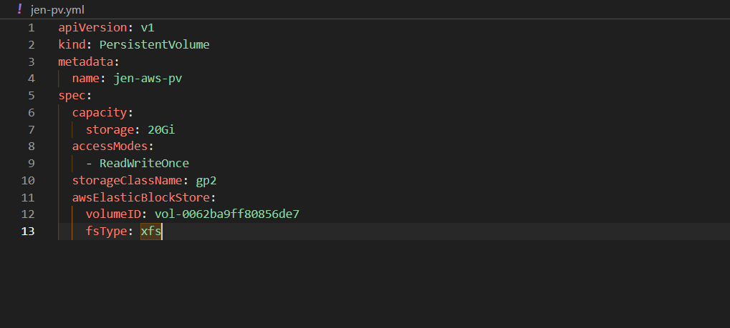

* Create the Persistent Volume Claim that will take a partition of the Persistent Volume

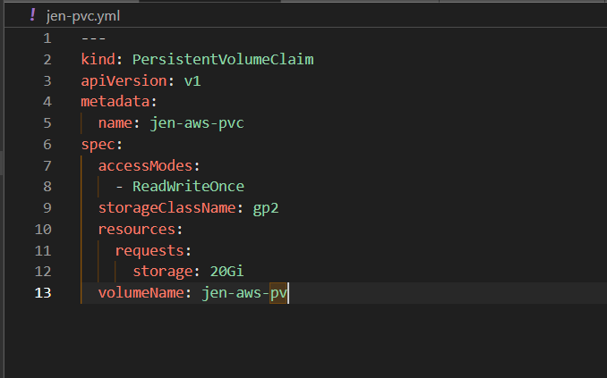

After the pvc are created, the status should be bound

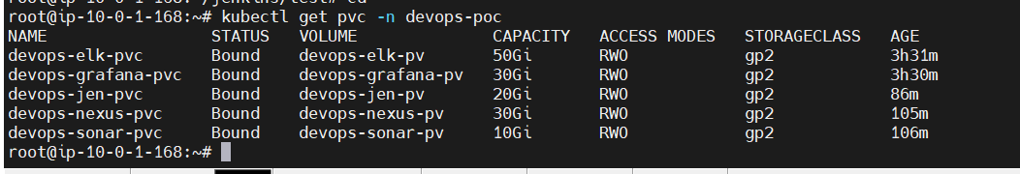

Now, mount this PVC to the pod.

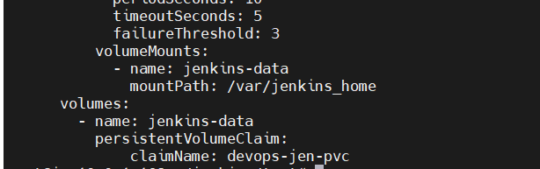

* Now we can check the mount volume :

kubectl exec -it nameOfPod -- /bin/bash

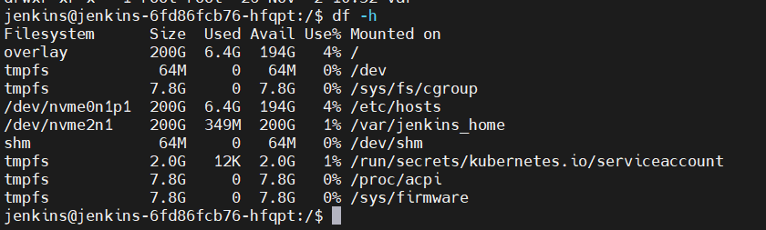

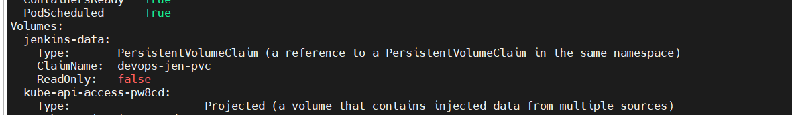

Pros

Storing and archiving the logs

Useful for application handling a large number of batch jobs

Independent from PODs life-cycle

Easy to backup

